Họ và Tên: Cáp Kim Khánh
MSSV: 102230192
Lớp Học Phần: 23T_DT1
Bài 1: Tìm min f(x,y,z) bằng 3 phương pháp:
- Newton method
Chương Trình:
#include <iostream>
#include <vector>
#include <cmath>
#include <iomanip>
using namespace std;

//Định nghĩa hàm f(x, y, z)
double f(const vector<double>& X)
{
double x = X[0];
double y = X[1];
double z = X[2];

return 0.5 * (x*x + 2*y*y + 3*z*z)
+ 0.1 * sin(x + y)
+ 0.1 * cos(y - z);
}

//Đạo hàm gần đúng (sai phân trung tâm)
double numericalDerivative(const vector<double>& X, int i, double (*f)(const vector<double>&), double h = 1e-6)
{
vector<double> X_plus = X;
vector<double> X_minus = X;
X_plus[i] += h;
X_minus[i] -= h;
return (f(X_plus) - f(X_minus)) / (2*h);
}

//Đạo hàm bậc 2 gần đúng (Hessian phần tử chéo)
double numericalSecondDerivative(const vector<double>& X, int i, double (*f)(const vector<double>&), double h = 1e-5)
{
vector<double> X_plus = X;
vector<double> X_minus = X;
X_plus[i] += h;
X_minus[i] -= h;
return (f(X_plus) - 2*f(X) + f(X_minus)) / (h*h);
}

// Newton Method ND (Hessian chéo giả định độc lập)
vector<double> newtonND(vector<double> X0, double (*f)(const vector<double>&),
int maxIterations = 1000, double eps = 1e-8)
{
int n = X0.size();

for (int iter = 1; iter <= maxIterations; ++iter)
{
vector<double> grad(n), hessianDiag(n);

// Gradient và Hessian chéo
for (int i = 0; i < n; ++i)
{
grad[i] = numericalDerivative(X0, i, f);
hessianDiag[i] = numericalSecondDerivative(X0, i, f);
}

vector<double> newX(n);
bool diverged = false;

for (int i = 0; i < n; ++i)
{
if (fabs(hessianDiag[i]) < 1e-10)
{
diverged = true;
break;
}
newX[i] = X0[i] - grad[i] / hessianDiag[i];
}

if (diverged)
{
cout << "The zero-element Hessian cannot converge at step" << iter << endl;
break;
}

if(iter % 100 == 0){
cout << "Iteration " << setw(4) << iter << ": ";
for (double xi : X0) cout << setw(10) << fixed << setprecision(6) << xi << " ";
cout << " f = " << f(X0) << endl;
}

// Kiểm tra hội tụ
double maxChange = 0;
for (int i = 0; i < n; ++i)
maxChange = max(maxChange, fabs(newX[i] - X0[i]));

if (maxChange < eps)
{
cout << "\n Convergence after " << iter << " loop.\n";
return newX;
}

X0 = newX;
}

cout << "\n Không hội tụ sau " << maxIterations << " vòng lặp.\n";
return X0;
}

int main()
{
vector<double> initialX = {-1.0, 2.0, 1.0};
cout << "Newton Method for n-dimensional function (numerical derivatives):\n";

vector<double> result = newtonND(initialX, f, 1000, 1e-8);

cout << "\n Minimum at: ";
for (double xi : result) cout << xi << " ";
cout << "\n Function value = " << f(result) << endl;

return 0;
}

Kết Quả:
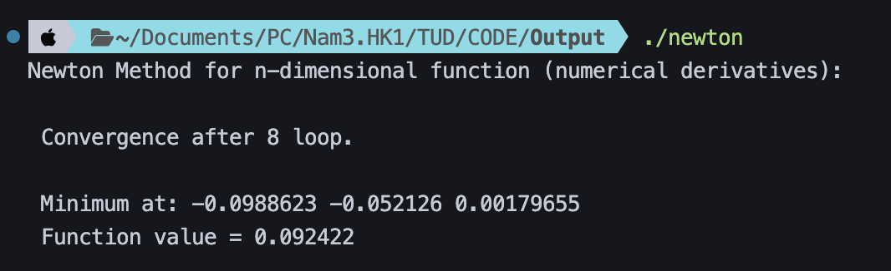
- Gradient Descent
Chương Trình:
#include <iostream>
#include <vector>
#include <cmath>
#include <iomanip>

using namespace std;

//Hàm mục tiêu
double f(const vector<double>& X)
{
double x = X[0];
double y = X[1];
double z = X[2];

return 0.5 * (x*x + 2*y*y + 3*z*z)
+ 0.1 * sin(x + y)
+ 0.1 * cos(y - z);
}

// Đạo hàm số học với step h nhỏ
double numericalDerivative(const vector<double>& X, int i, double (*f)(const vector<double>&), double h = 1e-6)
{
vector<double> X_plus = X;
vector<double> X_minus = X;
X_plus[i] += h;
X_minus[i] -= h;
return (f(X_plus) - f(X_minus)) / (2*h);
}

// Gradient Descent n biến
vector<double> gradientDescentND(vector<double> initialX, double learningRate, int maxIterations, double (*f)(const vector<double>&))
{
int n = initialX.size();
vector<double> X = initialX;

for (int iteration = 1; iteration <= maxIterations; ++iteration)
{
vector<double> grad(n);
for (int i = 0; i < n; ++i)
grad[i] = numericalDerivative(X, i, f);

vector<double> newX(n);
for (int i = 0; i < n; ++i)
newX[i] = X[i] - learningRate * grad[i];

// In ra mỗi 100 vòng để dễ theo dõi
if (iteration % 100 == 0)
{
cout << "Iteration " << iteration << ": ";
for (double xi : X) cout << fixed << setprecision(6) << xi << " ";
cout << ", Function Value = " << f(X) << endl;
}

// Kiểm tra hội tụ
double maxChange = 0;
for (int i = 0; i < n; ++i)
maxChange = max(maxChange, fabs(newX[i] - X[i]));

if (maxChange < 1e-8) // chuẩn hội tụ nhỏ hơn
break;

X = newX;
}

return X;
}

int main()
{
vector<double> initialX = {-1.0, 2.0, 1.0};
double gamma = 0.01; //hệ số học
int maxIterations = 10000;

cout << "Gradient Descent for n-dimensional function:" << endl;
vector<double> result = gradientDescentND(initialX, gamma, maxIterations, f);

cout << "Minimum at: ";
for (double xi : result) cout << xi << " ";
cout << "\nFunction value = " << f(result) << endl;

return 0;
}

Kết Quả:
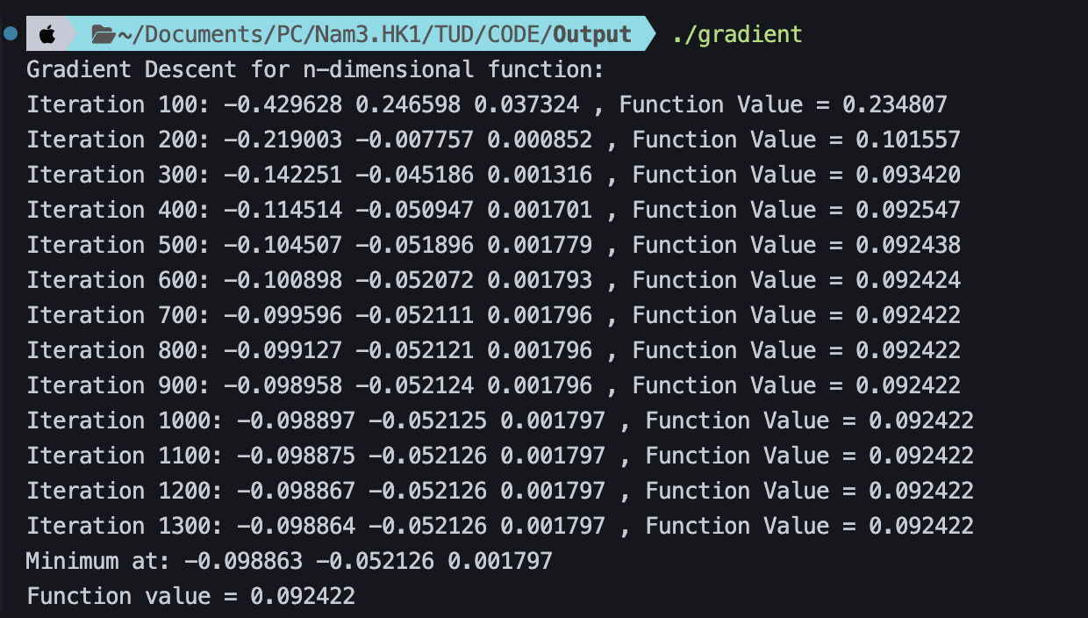
- Gradient Descent with Momentum
Chương Trình:
#include <iostream>
#include <vector>
#include <cmath>
#include <iomanip>

using namespace std;

// Hàm f(X) của bạn (không đổi)
double f(const vector<double>& X)
{
double x = X[0];
double y = X[1];
double z = X[2];

return 0.5 * (x*x + 2*y*y + 3*z*z)
+ 0.1 * sin(x + y)
+ 0.1 * cos(y - z);
}

// Hàm tính đạo hàm số học (không đổi)
double numericalDerivative(const vector<double>& X, int i, double (*f)(const vector<double>&), double h = 1e-6)
{
vector<double> X_plus = X;
vector<double> X_minus = X;
X_plus[i] += h;
X_minus[i] -= h;
return (f(X_plus) - f(X_minus)) / (2*h);
}

// === Gradient Descent with Momentum ===
vector<double> gradientDescentWithMomentum(
vector<double> initialX,
double learningRate, // Đây là gamma
double alpha, // Đây là hệ số động lượng
int maxIterations,
double (*f)(const vector<double>&)
)
{
int n = initialX.size();
vector<double> X = initialX;

// Khởi tạo vector vận tốc (momentum)
vector<double> v(n, 0.0);

for (int iteration = 1; iteration <= maxIterations; ++iteration)
{
// 1. Tính Gradient (như cũ)
vector<double> grad(n);
for (int i = 0; i < n; ++i)
grad[i] = numericalDerivative(X, i, f);

vector<double> newX(n);
for (int i = 0; i < n; ++i)
{
// 2. Cập nhật vận tốc: v_k = alpha * v_(k-1) + gamma * g_k
v[i] = alpha * v[i] + learningRate * grad[i];

// 3. Cập nhật vị trí: X_(k+1) = X_k - v_k
newX[i] = X[i] - v[i];
}

// In ra mỗi 100 vòng để dễ theo dõi
if (iteration % 100 == 0)
{
cout << "Iteration " << setw(5) << iteration << ": ";
for (double xi : X) cout << fixed << setprecision(6) << xi << " ";
cout << ", Function Value = " << f(X) << endl;
}

// Kiểm tra hội tụ (như cũ)
double maxChange = 0;
for (int i = 0; i < n; ++i)
maxChange = max(maxChange, fabs(newX[i] - X[i]));

if (maxChange < 1e-8)
{
cout << "\n Convergence after " << iteration << " loop." << endl;
break;
}

X = newX;
}

return X;
}

int main()
{
vector<double> initialX = {-1.0, 2.0, 1.0};
double gamma = 0.01; // Tốc độ học (Learning Rate)
double alpha = 0.9; // Hệ số động lượng (Momentum)
int maxIterations = 10000;

cout << "Gradient Descent with Momentum for n-dimensional function:" << endl;
cout << "Initial X: ";
for (double xi : initialX) cout << xi << " ";
cout << endl;
cout << "Learning Rate (gamma) = " << gamma << ", Momentum (alpha) = " << alpha << endl;

vector<double> result = gradientDescentWithMomentum(initialX, gamma, alpha, maxIterations, f);

cout << "Minimum at: ";
for (double xi : result) cout << fixed << setprecision(8) << xi << " ";
cout << "\nFunction value = " << f(result) << endl;

return 0;
}
Kết Quả:
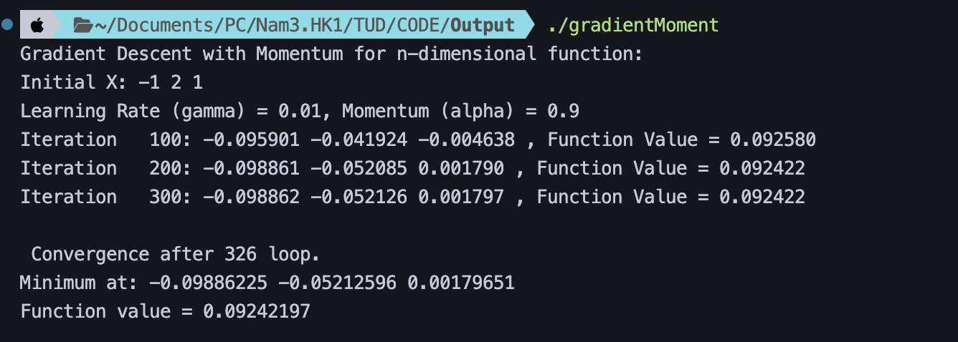

Bài 2: Tìm min f(x,y,z) bằng phương pháp ALM
Chương Trình:
#include <iostream>
#include <iomanip>
#include <cmath>
#include <vector>
#include <functional>
using namespace std;

const double EPS = 1e-6;
const int MAX_OUTER = 50;
const int MAX_INNER = 1000;
const double STEP = 1e-6;

//Hàm mục tiêu
double f(const vector<double>& X)
{
double x = X[0];
double y = X[1];
double z = X[2];

return x * x + y * y + z * z;
}

//Hàm ràng buộc
vector<function<double(const vector<double>&)>> hfuncs = {
[](const vector<double>& X) { return X[0] + X[1] + X[2] - 1; }
};

//Đạo hàm
vector<double> numericalDerivative(function<double(const vector<double>&)> func,
const vector<double>& X, double step = STEP)
{
int n = X.size();
vector<double> grad(n);
for (int i = 0; i < n; ++i)
{
vector<double> X_plus = X, X_minus = X;
X_plus[i] += step;
X_minus[i] -= step;
grad[i] = (func(X_plus) - func(X_minus)) / (2 * step);
}
return grad;
}

//gradientMoment
vector<double> gradientMoment(function<double(const vector<double>&)> L,
vector<double> X)
{
double alpha = 0.1;
int n = X.size();

for (int iter = 0; iter < MAX_INNER; ++iter)
{
vector<double> grad = numericalDerivative(L, X);
double gnorm = 0.0;
for (double g : grad) gnorm += g * g;
gnorm = sqrt(gnorm);
if (gnorm < 1e-8) break;

double f_current = L(X);
bool found = false;
vector<double> newX = X;

// Backtracking line search
for (int ls = 0; ls < 20; ++ls)
{
for (int i = 0; i < n; ++i)
newX[i] = X[i] - alpha * grad[i];

double f_new = L(newX);
if (f_new < f_current - 1e-4 * alpha * gnorm * gnorm)
{
found = true;
break;
}
alpha *= 0.5;
}

if (!found) alpha = 0.01;
else alpha = min(alpha * 1.1, 1.0);

X = newX;
}
return X;
}

int main()
{
cout << fixed << setprecision(6);

vector<double> X = {1.0, 2.0, 1.5}; // initial guess (x, y, z)
double lambda = 0.0;
double r = 1.0;

cout << setw(8) << "Iter"
<< setw(12) << "lambda"
<< setw(10) << "r"
<< setw(15) << "x"
<< setw(15) << "y"
<< setw(15) << "z"
<< setw(15) << "h(x)" << endl;
cout << string(85, '-') << endl;

for (int outer = 1; outer <= MAX_OUTER; ++outer)
{
// Build augmented Lagrangian L(X)
function<double(const vector<double>&)> L = [&](const vector<double>& Xv) {
double val = f(Xv);
for (auto& h : hfuncs)
{
double hv = h(Xv);
val += lambda * hv + 0.5 * r * hv * hv;
}
return val;
};

// Minimize L(X, λ, r)
vector<double> newX = gradientMoment(L, X);
double h_val = hfuncs[0](newX);
double f_val = f(newX);

cout << setw(8) << outer
<< setw(12) << lambda
<< setw(10) << r
<< setw(15) << newX[0]
<< setw(15) << newX[1]
<< setw(15) << newX[2]
<< setw(15) << h_val << endl;

// Update λ and r
lambda += r * h_val;
if (fabs(h_val) > 1e-3)
r *= 1.5;

// Check convergence
if (fabs(h_val) < EPS)
{
cout << "\n Converged after " << outer << " iterations.\n";
cout << "Minimum at: (" << newX[0] << ", " << newX[1] << ", " << newX[2] << ")\n";
cout << "f(x) = " << f_val << endl;
return 0;
}

X = newX;
}

cout << "\n Did not converge after " << MAX_OUTER << " iterations.\n";
return 0;
}

Kết Quả:
